
Guidance on Balancing Rights
The FAIR model, developed by the Scottish Human Rights Commission, supports duty bearers in taking a human rights-based approach towards decision-making.
Duty bearers have requested that the National Collaborative offer guidance on using the FAIR model in specific contexts where challenges arise due to competing rights and may need to be balanced with one another.
Two examples given by duty bearers were the prioritisation of services and information sharing.
In response to this request, the below guidance illustrates how the FAIR model can be adapted to the context of prioritisation of services.
It needs to be understood that this is guidance on how to apply a human rights-based approach rather than a comprehensive guidance on the full range of legal requirements on duty bearers.
For example, in regards to information sharing, reference would need to be made to the Data Protection Act requirements and available legal guidance.
Accordingly, as part of the national implementation plan of the Charter an InterAction is proposed to be held to explore with a broad range of interested parties, the development of human rights-based guidance on information sharing.

The FAIR Process of a Human Rights-Based Approach for Balancing Rights
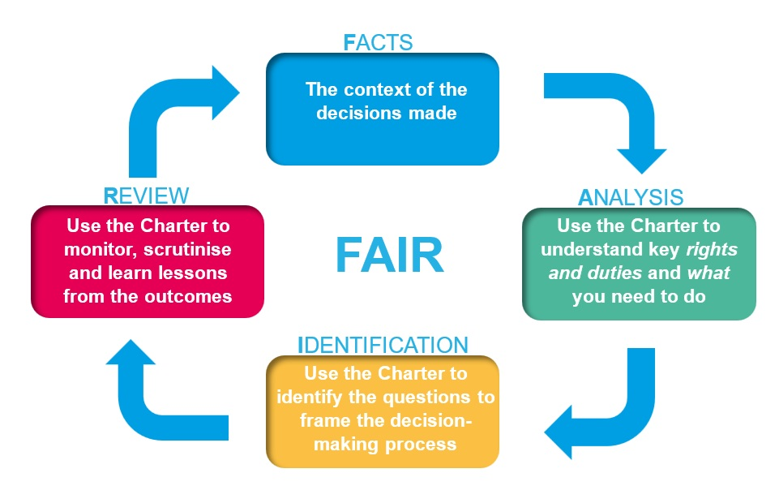

How to use the Charter of Rights to help you to decide on prioritisation of services

Four Key Recommended Steps for Balancing Rights in Prioritisation of Services
Step 1 - Facts
What is the specific challenge facing the duty bearer in balancing rights?
For example, the service provider may need to decide which services to prioritise within the context of reduced or limited resources. This will be demanding and could require balancing competing claims, rights, and duties.
Step 2 - Analysis
What are the kinds of competing rights which are at stake and need to be balanced, particularly in circumstances of reduced or limited resources?
- “Absolute” rights
The Human Rights Act 1998 includes the right to life under Article 2 and the right not to be subject to inhuman and degrading treatment under Article 3. They are defined in human rights law as “absolute” rights which must be met by all duty bearers.
So, where there is someone’s life at risk, or someone is at risk of being placed in a state of destitution then there should be service provision which is designed and delivered to prevent this happening.
In such circumstances, the relevant public authority has both a “negative” obligation not to do anything which breaches these rights but also a “positive” obligation to take steps to prevent any breaches of these rights through, for example, putting in place an appropriate service provision, be that health or social protection.
- “Qualified” rights
The Human Rights Act 1998 also includes rights which are defined as “qualified” rights. This means that they can be interfered with but only subject to certain conditions being met.
For example, Article 8 - “the right to a private and family life, home and correspondence” - is a qualified right.
However, in this regard it is important to consider that this right has also been interpreted by the courts as including the right to physical and psychological integrity, wellbeing, and autonomy. It therefore has a broader and much more significant reach than may at first appear from first reading.
Moreover, the courts have been clear that the relevant public authority has not only a “negative” obligation not to interfere with such rights, subject to certain conditions, but also has a “positive” obligation to take steps to respect such rights which can include the provision of appropriate public services.
Accordingly, where it is qualified rights which are at stake the relevant public authority needs to make a proportionate assessment in deciding which services to prioritise.
At the time of publication of the Charter, the Scottish Government is continuing to develop proposals for a new Scottish Human Rights Bill. Proposals for the Bill seek to incorporate the UN International Covenant on Economic, Social and Cultural Rights amongst other treaties into Scots law, within the limits of devolved competence. The proposals intend to introduce the right to the highest attainable standard of physical and mental health, among many other relevant rights.
This is a “qualified” right which would influence the prioritisation as well as the design, delivery and monitoring of healthcare services, including substance use, and the positive determinants of health including housing and income.
Those responsible for the prioritisation as well as design, delivery and monitoring of such public services would be required to so far as possible ensure the availability, accessibility, acceptability and quality – known as the “triple AAAQ” - of such services.
- Available services provide choice of healthcare support.
- Accessible services are inclusive and do not exclude anyone due to geographical or financial barriers.
- Acceptable services are inclusive, person-centred, gender-sensitive, family friendly and do not exclude anyone due to ethnicity, language, gender, mental health, or other status.
- Quality services are de-stigmatised, evidence-based, trauma informed, meaningfully involve individuals and families in decision-making and are subject to independent oversight.
Proposals for the Scottish Human Rights Bill intend to seek to require public authorities to demonstrate how their maximum available resources have been used to fulfil the right to health, that they have at least provided minimum standards to ensure everyone lives in dignity and no one in destitution and that they also have a plan to progressively realise the enjoyment of rights over time.
- Resource limitations
There are additional factors which need to be considered when balancing rights in the context of having to decide which services to prioritise due to reduced or limited resources.
There is a general principle of non-regression of human rights – no backward steps – but it is recognised that this may be unavoidable at certain times.
In such circumstances the following good practice guidance is applicable:
- Any reduction in public services should be as limited in duration as possible.
- Budget or service cuts should not be discriminatory or impact disproportionately upon a vulnerable part of society.
- The most disadvantaged should be prioritised.
- The government and relevant public authorities should ensure that minimum core standards are maintained to enable people to live in dignity and not be placed in destitution.
It is in the interests of the duty bearer to ensure that their above decision-making process is recognised policy and is transparent. This will support relations between the public authority and the public and the affected communities as well as provide assurance to the scrutiny bodies.
Step 3 - Identification
Proportionality (don’t use a sledgehammer to crack a nut) goes to the heart of the matter of identification of the steps to take in deciding how to prioritise services.
It is about the duty bearer trying to strike a fair and reasonable balance through making a proportionate assessment of the interests at stake when deciding which services to prioritise, particularly in circumstances of reduced or limited resources.
For example, whilst circumstances will vary the duty bearer should generally not use a sledgehammer to crack a nut.
The following questions are good practice guidance:
- what would be the impact upon those people affected by the reduction or removal of the service?
- who may be most at risk of being disproportionately impacted and suffer multiple disadvantages (intersectionality) resulting from cuts in services, (e.g. women who are in the least secure and least well-paid employment, also more likely to be family carers, also most vulnerable to domestic abuse, and who may be from minority ethnic communities, etc)?
- how many people would be affected by prioritising certain services over others?
- who are most in need of being prioritised (e.g. including consideration of Public Sector Equality Duties, Fairer Scotland duties)?
- would the provision of a specific service be a cost-effective use of limited resources or could rights be more effectively met through providing the service in a different way (e.g. partnership) or through a different service?
- would any reduction in service be a last resort and seek to minimise the impact upon the rights of those people affected?
- does the decision-making process enable meaningful public participation and enable scrutiny bodies to carry out oversight?

Step 4 - Review
How are the outcomes monitored, evaluated and lessons learned?
The outcomes of the balancing of rights and prioritisation of services decision should be monitored, evaluated and lessons learned by the service provider and by the relevant scrutiny bodies.
- The service provider needs to know if the decision on prioritisation of services achieved its purpose or, for example, whether there were unintended consequences.
- Using a human rights-based lens supported by the Charter and its Toolkit, including the Checklist and the FAIR approach, supports them in this monitoring and evaluation.
- The evaluation should include the experience of those people affected by the decision on prioritisation of services.
Lessons learned can then help improve the decision-making process.
- The relevant scrutiny bodies, such as Healthcare Improvement Scotland or the Care Inspectorate, should satisfy themselves that an appropriate decision-making process has been followed by the service provider.
- Using a human rights-based lens supported by the Charter and its Toolkit, including the Checklist and the FAIR approach, supports them in this oversight.
- It would also include the scrutiny bodies evaluating the outcomes through learning directly from the experience of those people affected by the decisions.

End of document.

