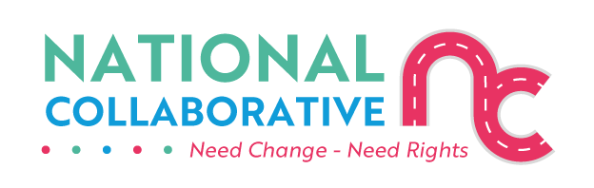
The FAIR Approach for Engagement between Frontline Service Providers and Individuals Affected by Substance Use
The Charter of Rights - and its Toolkit - will help you as a frontline service provider to improve how you support individuals affected by substance use.
It will also help you as someone affected by substance use to understand better what you should expect from those people providing support services to you.
‘FAIR’ is a model for putting the Charter into practice. The process is illustrated below:
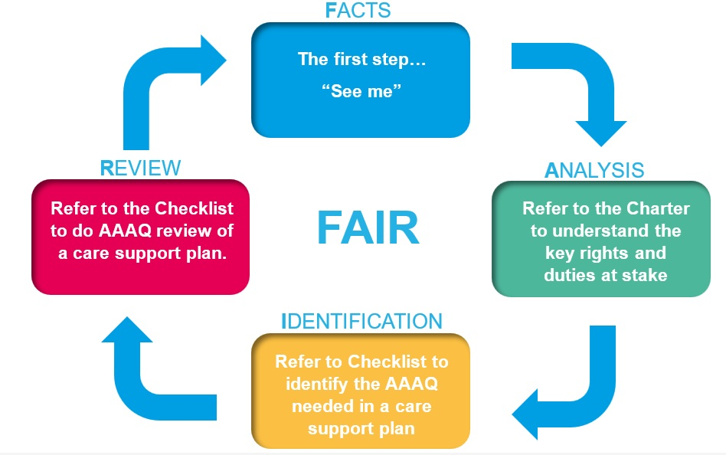
Some parts of this process may already be familiar to you – for example, the first step of F (Facts) is about understanding the whole person and is like taking a person-centred approach.
Let us work our way through the four steps of FAIR:
Step 1 – ‘F’ of ‘FAIR’
Facts
The first step is to “see me” – gather the facts and begin to understand the whole person and recognise that they have the same human right to be respected and treated with dignity as everyone else.
Ask them, listen and learn about what their current needs are.
This includes understanding…
- any trauma experienced
- the kind of healthcare support needed and wanted
- the social support networks they want to build on
- any support they need to get – e.g. adequate housing and income (these are what are called “positive determinants of good health”) and are part of the “right to health” in the Charter).

Step 2 – ‘A’ of ‘FAIR’
Analysis
Now that you understand the person’s needs, understand the human rights that relate to the needs they have talked about.
To do this, look at the Charter of Rights for People Affected by Substance Use which outlines the key human rights at page 6.
Let’s take the “right to the highest attainable standard of physical and mental health” as an example. It is a key right that will often be relevant.
This right – as well as all other rights – belongs to everyone without discrimination, including those people affected by substance use.
This right to health means that you should make every effort possible to work with people in a way that:
- offers them choice in the way they want to be supported (availability of care)
- is accessible to their needs – e.g. your service is affordable and located within easy reach, or you can come to them
- is acceptable to the person you are supporting – e.g. you are being an inclusive and person-centred worker, being gender-sensitive and family and child-friendly and not excluding anyone due to ethnicity, language, gender, mental health, or other status
- provides support that is of sufficient quality – e.g. being trauma-informed, stigma-free, and that you make space for the person you are supporting and their family, where appropriate, to be a part of the decision-making process
- do your best to support their obtaining the positive determinants of good health – e.g. adequate housing and income.
These ‘requirements’ of availability, accessibility, acceptability and quality of healthcare services – and of the positive determinants of health such as income and housing - are known as the “triple AAAQ” which can be an easy way to remember and do it all.
You can find more help on applying the triple AAAQ by looking at the Right to Health Checklist in the Charter of Rights Toolkit. This will help you with the next step of developing the care plan which we will now go on to look at.

Step 3 – ‘I’ of ‘FAIR’
Identification
Now that you understand both the needs and the rights of the person the next step is to identify the best care support plan possible.
To do this, use the Right to Health Checklist to support you to…
- Enable the person affected by substance use, and families if appropriate, to participate in a meaningful way and influence the development of the support plan
- Advise them of the support plan choices available
- Check if support needed to ensure accessibility to services included in the plan – e.g. financial and transport support
- Check if support necessary to ensure acceptability of the services included in the plan – e.g. family or child-friendly
- Check if any steps need to be taken to ensure the quality of the services included in the plan – e.g. de-stigmatised, trauma informed, evidence-based and involving the person and families, if appropriate, in how the service is delivered.
This Right to Health Checklist approach is aligned with other relevant policies, procedures and standards which you already follow, e.g. MAT Standards, and so using it will help you improve how you work.

Step 4 – ‘R’ of ‘FAIR’
Review
This final step will already be familiar to you and is about reviewing how the care support plan has been working.
Use the Right to Health Checklist to support you to…
- Check the extent to which the plan has in practice been providing sufficient choice of available services and sufficient accessibility, acceptability and quality of services.
- Include as part of the review the experience and views of the person affected by substance use.
Lessons learned can then help improve the way in which the care support plan provides choice of available services and their accessibility, acceptability and quality. You will be able do this in your monthly supervision.
Another benefit of you and your supervisor using the Right to Health Checklist to review the care support plans is that inspection bodies, such as Healthcare Improvement Scotland and the Care Inspectorate, may also use the Checklist when reviewing the performance of the service provider.

Conclusion
The FAIR approach will therefore improve the delivery of support services because both you as a frontline service provider and you as someone seeking support understand the steps which need to be taken.

End of document.

