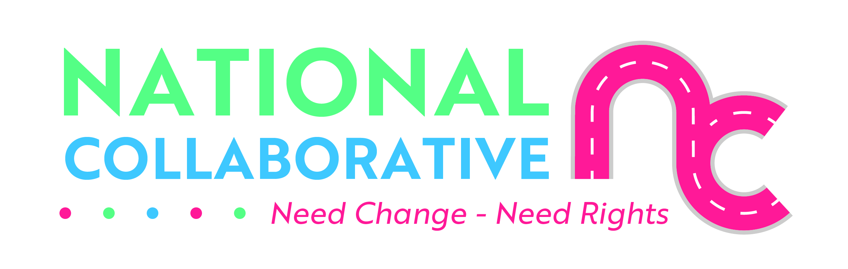
Charter of rights for people affected by substance use




Easy Read




What are human rights?
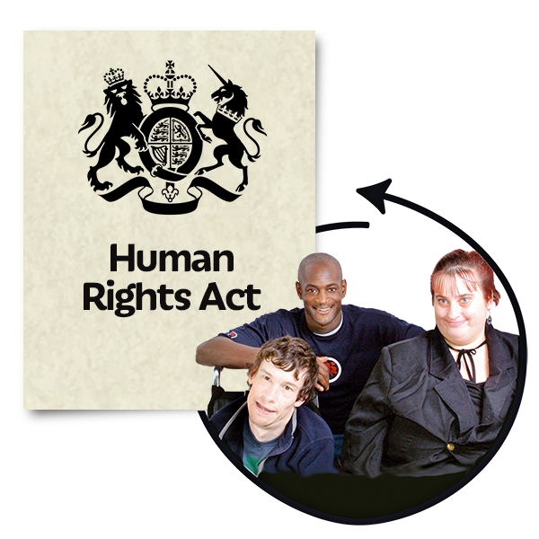 | A charter of rights is a document that sets out the rights and powers that someone has.  Human rights are freedoms that are protected in law.  They make sure we are all treated fairly and with dignity.  Everyone has human rights.
 | This Charter sets out some of the most important rights for people affected by substance use.  This means people who have used or still use drugs or alcohol and can include families.
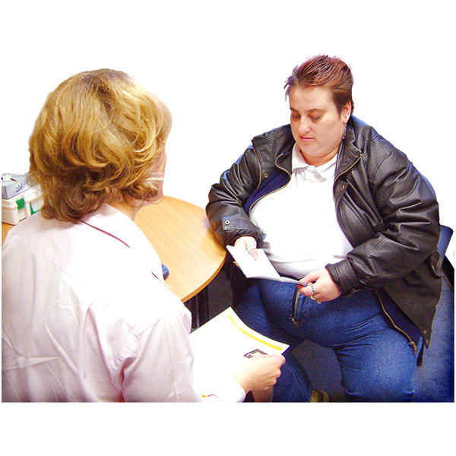 | The Charter helps people to:  - know their rights  - know what support they can get
 | The Charter has been made by:  - people affected by substance use  - family members and carers  - service providers  - national drug and alcohol support organisations
  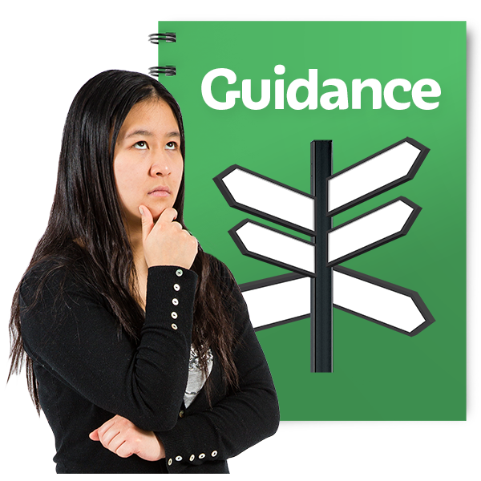 | The full version of the Charter and Toolkit can be found by:  - using the QR code on the left  - visiting the webpage at: alliance-scotland.org.uk  A toolkit is a pack of information that organisations can use for support and guidance.

Right to life
     | Everyone’s right to life is protected by law.  This means that everyone should be able to get things to support them to live longer lives like:  - treatment that works well  - support  - other interventions like services having plans to support someone when they leave residential care, police custody, prison or hospital  Services and organisations must work to protect people’s lives, especially people who are most at risk.

Right to the highest standard of physical and mental health
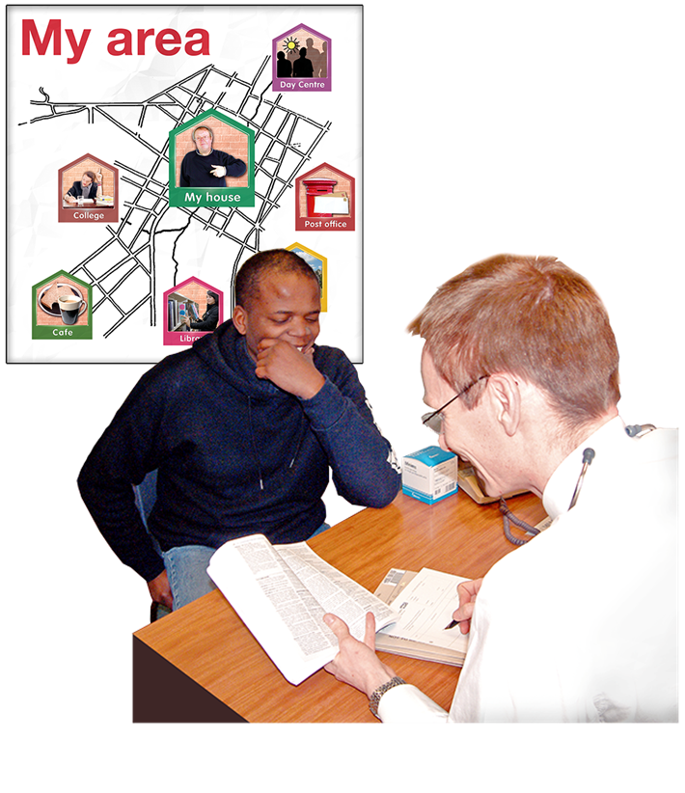   | Everyone has the right to get health and care services that:  - give them choices  - are affordable and are nearby  - are person-centred - listen to what a person wants and needs and has them at the centre of decisions that are made about their care  - are of the quality that is needed
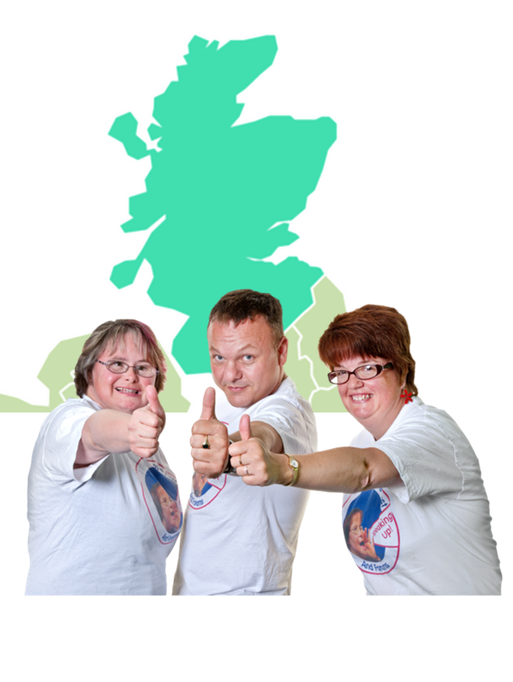 | Everyone should be treated fairly and equally whatever their health needs are and wherever they live in Scotland.
 | People should not be turned away from health and care services because they are using drugs or have used drugs in the past.

Right to a basic standard of living
   | Everyone has the right to services and things that support them to live in dignity.  Dignity means being treated in a way that recognises that you have the same human rights as everyone else.  This includes the right to have enough money to pay for your basic needs like food, heating or housing and to take part in the life of your community.
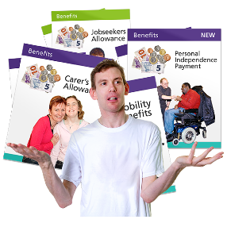 | The Government and public services should protect this right and make sure people get this right.  For example, people should be able to get the benefits they need.

Right to private and family life
   | Everyone has the right to respect for their family and private life.  This protects your dignity and right to make decisions about your own life.  This right can be limited but only to protect you or other people.
 | Family life includes the right to have and keep family relationships.
   | This includes:  - the right not to be separated from your family  - the right to keep in touch if your family is split up  For example a parent’s substance use should not be the only reason for:  - taking a child away from their parent  - stopping their parent from seeing their child
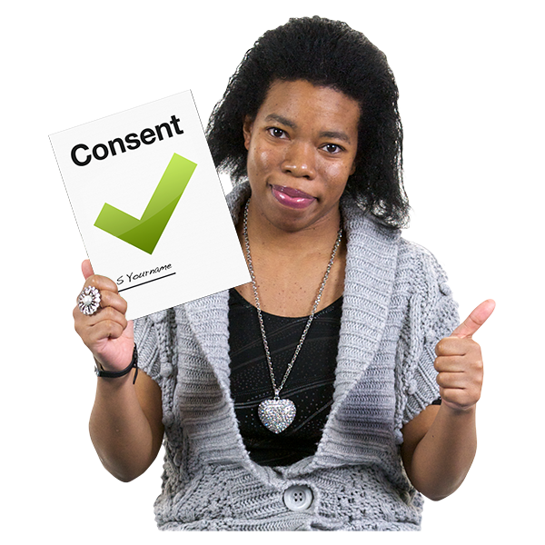 | Personal health data should only be shared:  - when the person has given their consent  - or when it is in the interests of the person, for example if their life is at risk  Consent means agreeing.
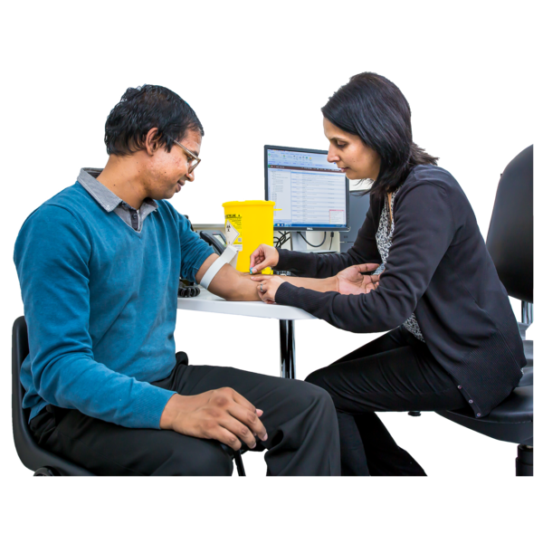 | Personal health data means information about your health including substance test results or what treatment you have had.
 | If a person does not give consent for their information to be shared staff can still meet with family members and carers to:  - listen to what they are worried about  - give advice

Right to a healthy environment – the area around us
 | This right includes having the things which support our physical and mental health like:  - clean air  - enough safe water  - clean and safe places to live, work, study and play in

Right to freedom from torture and other cruel treatment or punishment
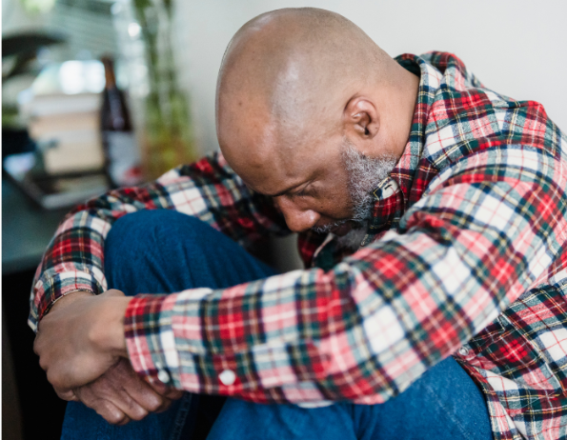 | Torture means making someone feel physical or mental pain as a punishment.  This right protects you from treatment which causes a lot of pain or makes you feel worthless or hopeless.
  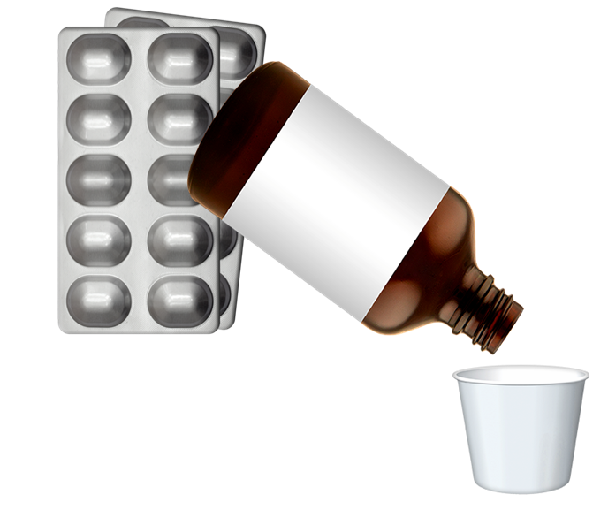   | Everyone should be able to get the medicine they need, including when they are in prison or in a police cell.  This includes medicine for:  - substance dependence  - pain treatment  - palliative care - caring for someone who is at the end of their life or who has a terminal illness

Freedom from arbitrary arrest or detention
  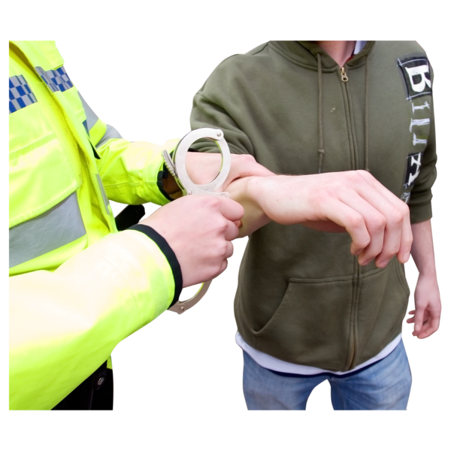 | This means someone being arrested or kept in a police cell without good reason.  This should not happen to someone just because they are using drugs or alcohol.  People who have broken the law because of their personal use of drugs and alcohol should be given support from social work or other support organisations.

Advocacy
 | Advocacy services give information, support and representation.  Advocacy can support you to get your views and wishes heard and explains more about your rights.
  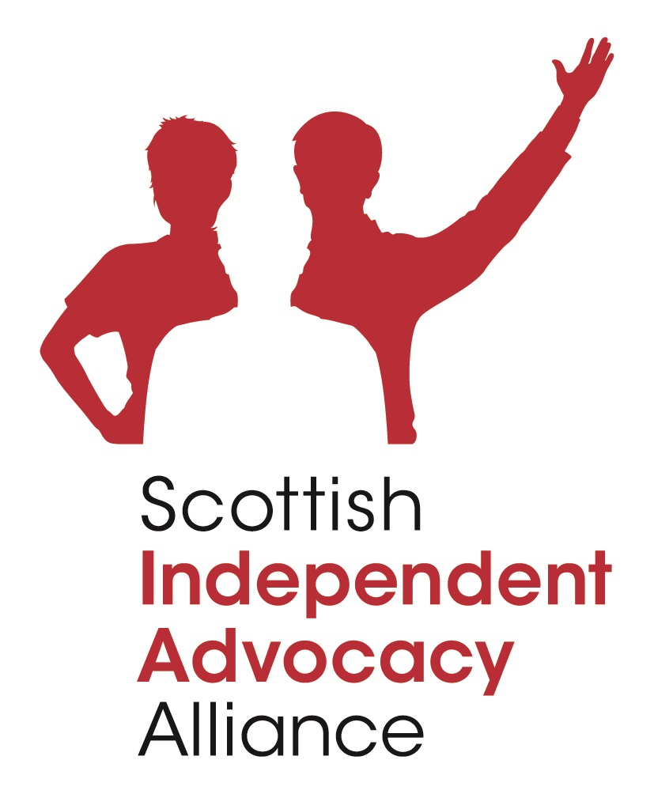 | The Scottish Independent Advocacy Alliance can help you to find an advocacy service.  Call them on: 0131 510 9410

Feedback and complaints
 | If your rights or the rights of someone you care for are not being met you can tell the service or make a complaint.  You should speak to the person most involved in giving the care or their manager.
   | You can give feedback without giving your name using Care Opinion.  You can call Care Opinion on Freephone 0800 122 3135.
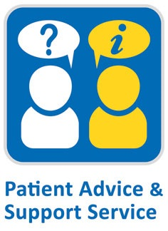     | For help and advice with NHS complaints, contact your local Patient Advice & Support Service (PASS)  The PASS Advice Line is: 0800 917 2127  It is open from Monday to Friday from 9am to 5pm.
 | The service is free, independent and confidential.  Confidential means your information will be kept private.
 | More information about complaints can be found online in the full Charter: alliance-scotland.org.uk

Additional images from Canva, National Collaborative, SIAA, Care Opinion and PASS.

