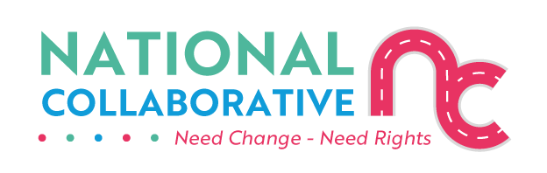
The FAIR model example of applying the Panel Principles to strengthen ADP/LLE engagement.

ADP/LLE engagement is a critical part of the implementation of the Charter of Rights at a local level. Key findings from our evidence-gathering sessions tell us that there is considerable room for improvement in the interactions between ADPs and LLE panels.
Accordingly, this guidance demonstrates how the FAIR model of applying the Panel Principles can support improved meaningful engagement between ADPs and LLE Panels and other relevant stakeholders including Reference Groups, LEROs and family organisations.
Meaningful engagement is where people are able to influence outcomes.
Accessible engagement is where existing community groups and informal networks are seen as assets and information is shared in a way that is easy to understand.
Inclusive engagement is where specific efforts are made to involve people who face multiple barriers and who are not often heard.

The FAIR model is an acronym for Facts, Analysis, Identification and Review and is illustrated below.
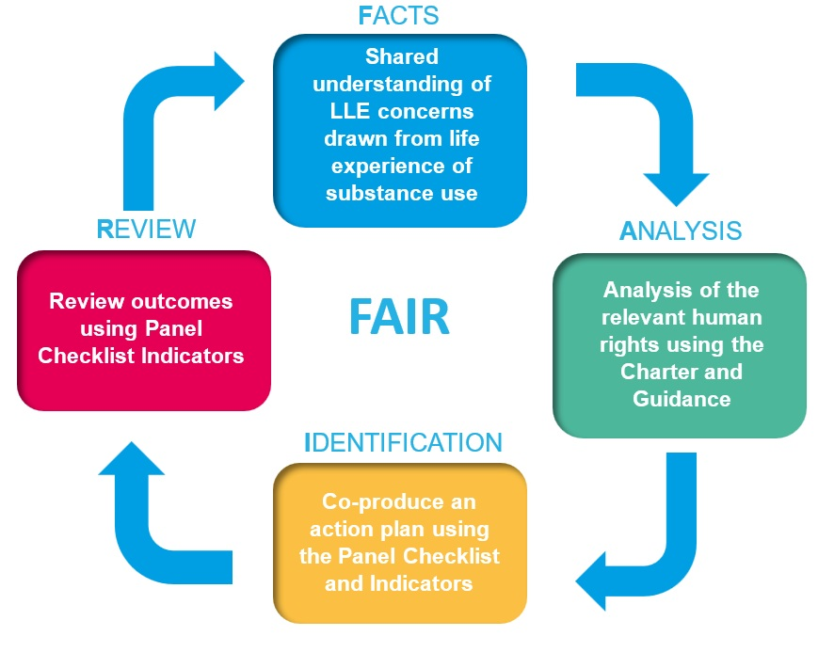

The FAIR Model is applied through taking the following steps.

Key recommendations are for LLE groups and ADPs together to take the following four steps:
- Facts – gather an evidence base on the life experience of people affected by substance use.
- develop a setting where the LLE Panel can bring its concerns, based upon the life experience of people affected by substance use, about the design, delivery, monitoring, and outcomes of support services,
- this should be a collaborative and non-adversarial setting, user-friendly and not bureaucratic and the agenda prepared and agreed together by the ADP and LLE Panel.

- Analysis – reach a shared understanding of the rights at stake.
- once there is a shared understanding of the concerns reference should be made to the Charter of Rights for guidance on any rights which may be at stake,
- for example, if the right to the highest attainable standard of physical and mental health is at stake then consideration should be given to its requirements of availability, accessibility, acceptability, and quality of support services.

- Identification – reach a shared understanding of an implementation plan.
- agree an implementation plan, drawing upon the Panel Principles Checklist and Indicators, on what needs to be done, how and by when to ensure that the rights are realised,
- for example, if it is the right to health which is at stake the plan should include concrete and targeted steps, prioritising those most subject to stigma and at risk, to ensure that the ADP and other relevant duty bearers use the maximum resources available to progressively improve the availability, accessibility, acceptability, and quality of support services.
- for availability, this may mean increasing the choice of available services,
- for accessibility, this may mean locating relevant services in a community hub,
- for acceptability, this may mean providing more child-friendly or family-friendly services, and
- for quality it may mean improving trauma informed delivery of services.
Reference should be made to the Panel Principles Checklist and Indicators which can be adapted as appropriate in the local circumstances.

- Review – reach a shared understanding of progress indicators including an evaluation of the outcomes based upon the life experience of people affected by substance use.
- use agreed indicators, drawing from the Panel Principles Checklist and Indicators, to evaluate the outcomes,
- these indicators should include all relevant factors such as learning from the experience of those people who are attempting to engage with services and those people who are not,
- the available resources and a realistic timeline,
- this evaluation of outcomes will then help identify lessons to be learned by all.

Concerns which emerge from this evaluation of outcomes will then, along with any new areas of concern of the LLE Panel, inform the next application of the FAIR process. The FAIR model is then to be understood as a continuous improvement cycle of support services for people affected by substance use.

End of document.

